Final Year Design Project System Requirement Specification

CryptoSence

Final Year Design Project SRS

Project ID:22-KS-BSIT-16

By

Hamza Nadeem 089305(2022-KS-171)

Syed Mohsin Abbas 089330(2022-KS-178)

(Evening)

Project Advisor:

Muhammad Kamran

Govt. Graduate College, Civil Lines, Sheikhupura

University of the Punjab Lahore, Pakistan

(2025)
CryptoSence

Executive Summary
CryptoSence is a web-based cryptocurrency dashboard enhanced with a secure login system and an AI chatbot. It allows users to view real-time crypto prices, analyze charts, and interact with an intelligent assistant for insights, definitions, and recommendations. The system integrates CoinGecko API for live market data and OpenAI API for AI chatbot responses. A Node.js and Express are backend manages authentication, while MongoDB stores user data securely.

Contents
Executive Summary 2
Requirements Analysis 5
User Classes and Characteristics 5
Requirement Identifying Technique 5
Functional Requirements 5
Functional Requirement 1 6
Functional Requirement 2 6
Functional Requirement 3 6
Functional Requirement 4 7
Functional Requirement 5 7
Functional Requirement 6 8
Functional Requirement 7 8
Functional Requirement 8 8
Non-Functional Requirements 9
Reliability 9
Usability 9
Performance 9
Security 9
External Interface Requirements 10
User Interface Requirements 10
Software Interfaces 10
Hardware Interfaces 10
Communication Interfaces 10
Use Case Analysis 11
Use Case #1 – Registration 11
Use Case #2 – Login 11
Use Case #3 – Forget password 12
Use Case #4 – Google Sign in/up 13
Use Case #5 – View Crypto Dashboard 14
Use Case #6 – AI Bot 14
Use Case #7 – Crypto Education Support 15
Use Case #8 – Logout 16
Use Case Diagram: 17
Storyboards 18
Summary 19
References 19

List of Table
Table 1 Functional Requirement 1 6
Table 2 Functional Requirement 2 6
Table 3 Functional Requirement 3 6
Table 4 Functional Requirement 4 7
Table 5 Functional Requirement 5 7
Table 6 Functional Requirement 6 8
Table 7 Functional Requirement 7 8
Table 8 Functional Requirement 8 8
Table 9 Use Case 1 11
Table 10 Use Case 2 11
Table 11 Use Case 3 12
Table 12 Use Case 4 13
Table 13 Use Case 5 14
Table 14 Use Case 6 14
Table 15 Use Case 7 15
Table 16 Use Case 8 16
List of Figure
Figure 1 Use Case Diagram for End User 17

Requirements Analysis
The requirement analysis is a part of SRS which define what the cryptosence do functionally and non-functionally. The main point is to create an intelligent crypto analysis platform that is secure, scalable, and easy to use.

User Classes and Characteristics

The Cryptosence have only one user class, End user.

User Class | User Characteristics
End user | The End user could be crypto trader, financial analyst and students which take crypto real time price tracker and AI chat for trading support

Requirement Identifying Technique

The identifying requirements need to meeting with stackeholder by following step:
- Interview:
We conducted interviews with stakeholders which involve crypto trader, crypto teachers, financial analyst and WhatsApp crypto user groups to record user requirements.
- Ethnography and Observation:
We observed that users need a system that provides real-time cryptocurrency price tracking and AI-powered support for analyzing market trends and making predictions. This system would help traders perform market analysis and make informed trading decisions without the need to visit multiple websites.
- Use Case Analysis:
Defined interactions between users and system modules (Login, Dashboard, Chabot, Education support).

Functional Requirements

This section describes the functional requirements of the system expressed in the natural language style. This section is typically organized by feature as a system feature name and specific functional requirements associated with this feature. So, for each module and it’s feature the functional requirements are itemized below:

Functional Requirement 1
Table 1 Functional Requirement 1
Identifier | FR-1
Title | User Registration
Requirement | The user shall be able to register by entering username, email and password then account create
Source | Business Requirement
Rationale | Provide access control and data security.
Business Rule | Password must be at least 8 characters and other also include number
Dependencies | FR-2
Priority | High

Functional Requirement 2
Table 2 Functional Requirement 2
Identifier | FR-2
Title | User Login
Requirement | The user should be login by entering email and password then view the dashboard
Source | Business Requirement
Rationale | Provides access control and data security.
Business Rule | User must be registered before sign in.
Dependencies | FR-1
Priority | High

Functional Requirement 3
Table 3 Functional Requirement 3
Identifier | FR-3
Title | Forget password
Requirement | The user shall be able to reset their password by email A reset link will be sent to the provided email and allowing the user to create a new password
Source | Business Requirement and interview
Rationale | The users regain access if they forget their password
Business Rule | The email must be registered and verified before sending the reset link
Dependencies | FR-2
Priority | High

Functional Requirement 4
Table 4 Functional Requirement 4
Identifier | FR-4
Title | Google Sign-In/Up
Requirement | The user should be sign in/up by google account
Source | Business Requirement and interview
Rationale | Very simple process
Business Rule | Must have an google account of user
Dependencies | None
Priority | High

Functional Requirement 5
Table 5 Functional Requirement 5
Identifier | FR-6
Title | View crypto data
Requirement | The user can access real time price, percentage coin and market data, search bar for searching any currencies and also view crypto currencies charts and other update which you went to know.
Source | Business Requirement and interview
Rationale | Main functionality for traders
Business Rule | Must have good internet access
Dependencies | FR-1, FR-2, FR-3
Priority | High

Functional Requirement 6
Table 6 Functional Requirement 6
Identifier | FR-6
Title | Ai bot
Requirement | The user can know about any cryptocurrencies prediction, trends and also few line of explanation about cions
Source | Interview, Observation
Rationale | Improve the analysis of the user and market analysis
Business Rule | Need best internet support and knowledge about crypto
Dependencies | FR-1, FR-2, FR-3
Priority | High

Functional Requirement 7
Table 7 Functional Requirement 7
Identifier | FR-7
Title | Crypto education support
Requirement | The user can also access the best education platform, books and YouTube channel links which will be arranged in sequence of learning
Source | Interview, Observation
Rationale | Improve the skill of crypto trader and learners
Business Rule | If a student wants to learn crypto they should follow the steps in the order shown
Dependencies | FR-1, FR-3
Priority | Medium

Functional Requirement 8
Table 8 Functional Requirement 8
Identifier | FR-8
Title | logout
Requirement | The user went to logout from dashboard securely
Source | Observation
Rationale | Ensure user data security
Business Rule | User must be Login in the website
Dependencies | FR-2, FR-3
Priority | Medium

Non-Functional Requirements

These are constraints on the services or functions offered by the system. They include timing constraints, constraints on the development process, and constraints imposed by standards. Non-functional requirements often apply to the system as a whole rather than individual system features or services. Following are non-functional requirements:

Reliability
- The system should be up and running 99% of the time.
- It should retry automatically if API requests fail.

Usability
- The dashboard must be easy to use and reachable in 4 clicks or less.
- The chatbot should use simple English.
- The design should work well on both computers and mobiles.

Performance
- Dashboard data should load within 5 seconds.
- AI bot replies should come within 10 seconds.
- Database tasks should take less than 200 milliseconds.

Security
- Passwords are stored safely using bcrypt hashing.
- Login uses JWT (JSON Web Tokens) for authentication.
- The site uses HTTPS for secure data transfer.
- API keys are hidden in environment files.

External Interface Requirements
This section describes how our CryptoSence system will interact with users. It covers the user interface design, software connections, and communication methods.

User Interface Requirements
- Pages:
  - Login / Register Page
  - Dashboard (price tracker, chart section, search bar)
  - Chatbot Page
  - Crypto Education Support Page
- Design Elements:
  - Navbar with links to Dashboard, AI bot, Crypto education support and Logout
  - Card-based layout for coin data
  - Chat window for conversation with AI bot

Software Interfaces
- Frontend: React.js, HTML5, CSS3
- Backend: Node.js + Express.js
- Database: MongoDB
- APIs:
  - Coingecko (market data)
  - OpenAI API (chatbot)

Hardware Interfaces
- Runs on standard devices (laptop, mobile).
- Requires a good internet connection.

Communication Interfaces
- HTTPS protocol for secure communication.
- RESTful API endpoints for data and authentication.

Use Case Analysis

Use Case #1 – Registration
Table 9 Use Case 1
Use case ID | UC-1
Requirement traceability | Registration (FR-1)
Purpose | Purpose is to authenticate a user so they can access their dashboard
Priority | High
Preconditions | User must use accurate email and password for registration
Postconditions | When all requirement fulfil the user register and go to login page
Actor | End user
Extends | Google sign in/up
Main success scenario | - User open the website.  - Click the register button for registration.  - User enter the username, email, password and submit.  - The account creates according to giving data.  - And user login now.
Exceptions | If username, email and password are not fulfil the show error incomplete info and if not write password according to requirement so also show error password must be at least 8 characters
Includes | None

Use Case #2 – Login
Table 10 Use Case 2
Use case ID | UC-2
Requirement traceability | Login (FR-2)
Purpose | Purpose is to authenticate a user so they can access their dashboard
Priority | High
Preconditions | User must use accurate email and password for registration
Postconditions | When all requirement fulfil the user register and login
Actor | End user
Extends | Google sign in
Main success scenario | - User open the website.  - Click the register button for registration.  - User enter the username, email, password and submit.  - The account creates according to giving data.  - And user login now.
Exceptions | Wrong email or password show invalid login detail
Includes | Forget password

Use Case #3 – Forget password
Table 11 Use Case 3
Use case ID | UC-3
Requirement traceability | Forget password(FR-3)
Purpose | The purpose is that if user forget his password then change it
Priority | Medium
Preconditions | The email must be verify
Postconditions | The system updates the user password and sends confirmation of successful reset
Actor | End user
Extends | None
Main success scenario | - User opens the login page  - Clicks on the forgot password link  - Enters their registered email  - System verifies that the email  - System sends a password reset link to the email  - User clicks the reset link and reset the password
Exceptions | If email not registered show no account found
Includes | Email must be verify

Use Case #4 – Google Sign in/up
Table 12 Use Case 4
Use case ID | UC-4
Requirement traceability | Google sign in/up(FR-4)
Purpose | Purpose is to authenticate a user so they can access their dashboard by very simple process
Priority | High
Preconditions | The user must have google valid account.
Postconditions | User is authenticated via Google and redirected to Home or Profile Completion screen.
Actor | End user
Extends | None
Main success scenario | - User open the website.  - Click the register button for registration.  - User enter the username, email, password and submit.  - The account creates according to giving data.  - And user login now.
Exceptions | Google account Login fail  If no internet show check your connection
Include | Must have google account in system

Use Case #5 – View Crypto Dashboard
Table 13 Use Case 5
Use case ID | UC-5
Requirement traceability | View crypto dashboard(FR-5)
Purpose | The purpose after login user can view the real time price, charts and other market data of cryptocurrencies
Priority | High
Preconditions | User must have good internet connection.  User must be login in website.
Postconditions | The user can select any coin and see the data about it which including chart, current price and other data.
Actor | End user
Extends | Login and fetch crypto data
Main success scenario | - User login and redirected to home page.  - Access the crypto coins.  - The user searches any coin which they need.  - Select any coin and see the data and chart about the specific coin.
Exceptions | If API not responding show live data not available  If no internet show check your internet
Include | Searching and view charts of crypto currency

Use Case #6 – AI Bot
Table 14 Use Case 6
Use case ID | UC-6
Requirement traceability | Ai bot(FR-6)
Purpose | The ai bot purpose to help the user for identify trends and predication of any currencies
Priority | High
Preconditions | User logged in and chatbot page opened.
Postconditions | AI displays relevant answer.
Actor | End user
Extends | Analysis the coins of crypto
Main success scenario | - The user asks anything for it  - The ai process and reply  - If the data is out of limitation  - So it show error.
Exceptions | Network error show connection error
Include | Login

Use Case #7 – Crypto Education Support
Table 15 Use Case 7
Use case ID | UC-7
Requirement traceability | Crypto education support(FR-7)
Purpose | The purpose is to learn crypto trading
Priority | Medium
Preconditions | The user must be logged in.
Postconditions | The user can views the educational content or YouTube links.
Actor | End user
Extends | Download books and open playlist
Main success scenario | - User must be log in.  - User click on education button and the page display.  - The page displays YouTube links and learning content.  - User clicks a link to open and watch the video on YouTube.  - User continues learning by provided sequence.
Exceptions | Network error show connection error
Include | Login

Use Case #8 – Logout
Table 16 Use Case 8
Use case ID | UC-8
Requirement traceability | Logout (FR-8)
Purpose | The user logout securely from the website
Priority | Low
Preconditions | The user must be login.
Postconditions | When user logout then come to login page.
Actor | End user
Extends | None
Main success scenario | - User clicks the logout button.  - System confirms logout request.  - Then the user remove login.  - System redirects the user to the login page..
Exceptions | If network error show logout failed
Includes | Login

Use Case Diagram:
Figure 1 Use Case Diagram for End User

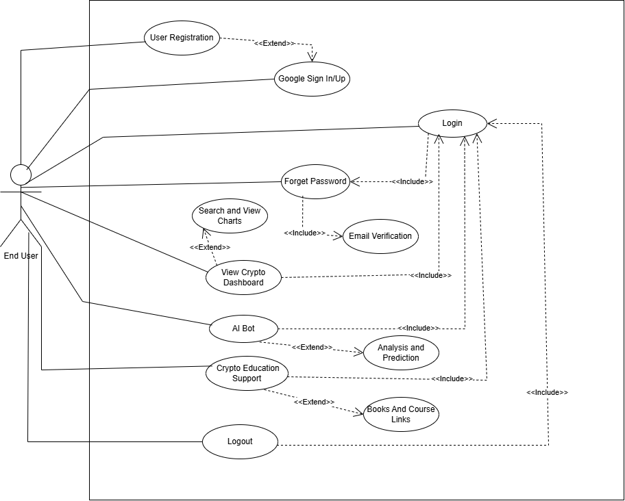

Storyboards
1. Login Page
- The user opens the CryptoSence website and is presented with the login page.
- The page includes fields for Email and Password and a button for Login.
- New users can click Register to create an account.
- After successful login user move to home page.
2. Dashboard Page
- The dashboard displays real-time cryptocurrency prices and market charts fetched from the coingecko API.
- A search bar allows the user to search any coin.
- Each coin shown inside a market data and charts of any coins.
- The nav bar provides links of Chabot, Learning, and Logout pages.
3. Chatbot Page
- The user clicks on AI Chabot in the navbar.
- The Chabot page opens with a chat display where the user can type messages or questions related to cryptocurrency.
- The Chabot reply intelligently using openai API
4. Learning (Education) Page
- The user navigates to the Education section.
- This page displays a list of YouTube course links and educational content related to cryptocurrency.
- Links are arranged in sequence from beginner to advanced.
- The user clicks any link to open the video in a new tab and learn from it.
5. Logout
- After completing activities, the user clicks the Logout button on the navigation bar.

Summary
The CryptoSence system integrates secure authentication, live crypto tracking, and AI-based insights into one platform. With real-time data via CoinGecko and conversational assistance via OpenAI, the project enhances both user learning and trading experience. It provides reliability, security, and an intuitive user interface designed for modern crypto enthusiasts.

References
Books
- Vaida, Bogdan. Zero to Hero in Cryptocurrency Trading: Learn to trade on a centralized exchange, understand trading psychology, and implement a trading algorithm. Birmingham, UK: Packt Publishing, 2023.
- Batish, Rachel. Voicebot and Chatbot Design: Build Conversational Experiences. London: Paradigm Publishing, 2018.
- Lewis, Antony. The Basics of Bitcoins and Blockchains: An Introduction to Cryptocurrencies and the Technology that Powers Them. London: Kogan Page, 2018.

Journal Articles
- Kumar, A. and Singh, R. “Web-Based Cryptocurrency Systems: A Review.” International Journal of Computer Applications, vol. 97, pp. 12–19, Mar. 2019.
- Chaves, Ana Paula; Egbert, Jesse; Hocking, Toby; Doerry, Eck; Gerosa, Marco Aurélio. “Chatbots Language Design: The Influence of Language Variation on User Experience.” arXiv preprint arXiv:2101.11089, Jan. 2021.
Conference Proceedings
- Javed, M. and Ali, H. “Designing Secure Web Portals for Crypto Services.” In Proc. International Conference on Information Systems, 2020, pp. 221–230.
- Rahman, T. “User-Friendly Interfaces for AI Chatbots.” In Proc. Global IT Summit, 2021, pp. 112–118.
World Wide Web
- CoinGecko. “CoinGecko API Documentation.” Internet: https://www.coingecko.com/en/api, n.d. [Accessed: Nov. 11, 2025].
- OpenAI. “OpenAI API Documentation.” Internet: https://platform.openai.com/docs, n.d. [Accessed: Nov. 11, 2025].
- MongoDB. “MongoDB Atlas Documentation.” Internet: https://www.mongodb.com/atlas, n.d. [Accessed: Nov. 11, 2025].
- Express.js Team. “Express.js Documentation.” Internet: https://expressjs.com/, n.d. [Accessed: Nov. 11, 2025].
- React Team. “React.js Official Documentation.” Internet: https://react.dev/, n.d. [Accessed: Nov. 11, 2025].

